1.1 Integers and Rational Numbers
List a few integers

List some numbers that are not integers

When we multiply, the numbers that are multiplied together are called _____________

List the factors of the following:

2

4

6

7

1

Prime numbers are numbers that have exactly _________ factors (what are they?)

Composite numbers have how many factors?

Is 1 prime or composite?

Find the prime factoration of 91

Find the prime factorization of the following numbers:

24 120

12 31

List the multiples of the following numbers:

4

6

Find the least common multiple of 4 and 6

Find the least common multiple of 6 and 8

Find the LCM of 12, 45, and 72

What fraction of the whole is shaded in?

What fraction corresponds to the location on the number line?
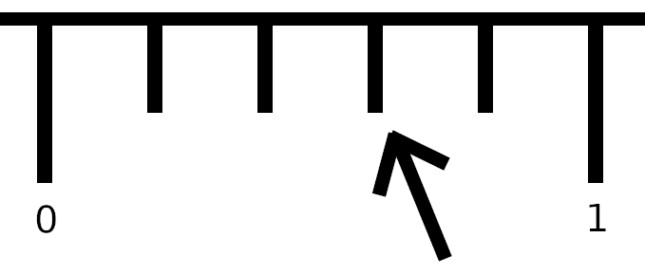

Fractions that are equal but have different numbers are _____________________

Write a fraction that is equal tobut has a denominator of 20

Find the LCD of and , then convert both fractions to that denominator

Write and as equivalent fractions with the least common denominator.

A fraction whose numerator and denominator share no common factor other than 1 are said to

be _________________________

Write the following in lowest terms

Find the following

The opposite of 6

The opposite of -7

The opposite of 0

The opposite of 4 - x

The absolute value of a is written ____________, and means the distance from 0 to a.

Find the following

|3|

|-4|

|0|

-|-1.5|

Section 1.2 - Addition of Rational Numbers
Adding integers with the same sign - add their absoute values, keep the sign the same
-7 + -4

8 + 6

Adding integers with opposite signs - find the difference and take the sign of the one that's farther from zero
-5 + 3

7 + (-4)

-1 + 4

3 + (-5)

Add or Subtract Rational Numbers in Fractional Form
When adding (or subtracting) fractions with like denominators, add (or subtract) the numerators and keep the denominator the same

Simplify

When adding (or subtracting) fractions with unlike denominators, first convert them to the same denominator, then proceed as before

Simplify, give the answer in lowest terms

Simplify, give the answer in lowest terms

Section 1.3 Subtraction of Rational Numbers
The additive inverse (or opposite) of 'a' is written _____________

Adding any number to its opposite give the result of _____________

Find the additive inverse of the following
7

-4

0

Subtract Integers
Rewrite a - b using addition

Perform the operations
59 - (-21)

-32 - 146

-19 - (-40)

10 - 18 + 25

162 - (-46) + 80 - 274

Subtract rational numbers

The difference between two values is the change in that quantity
If a trains speed is modeled as s = 1.5t, find the change in the speed between t=2 seconds and t=6 seconds

Should this be a positive change, or a negative change?

The intensity of light hitting a detector from a light at a certain distance is found to be

What is the change in intensity as you move from 2m to 5m?

Should this be a positive change or a negative change?
Associative Property
Compare: (2 + 3) + 4 2 + (3 + 4) 2 + 3 + 4

What is the general form of the associative property of addition?

Compare: (2 - 3) - 4 2 - (3 - 4) 2 - 3 - 4

Is there an associative property of subtraction?

Commutative Property
Compare: 3 + 2 2 + 3

Compare: 1 + 2 + 3 1 + 3 + 2

What is the general form of the commutative property of addition?

Compare: 3 - 2 2 - 3

Compare: 1 - 2 - 3 1 - 3 - 2

Is there a commutative property of subtraction?

0 is called the _________________
Section 1.4 - Multiplication of Rational Numbers
Multiply Integers
The product of two positive numbers is ______________

The product of a positive number and a negative number is ______________

The product of two negative numbers is ______________

Multiply
2(-4) -6(5)

(-7)(-8) -25(18)

3⋅(-4)⋅(-7)

-8⋅(-1)⋅4⋅(-5)

Multiply Rational Numbers in Fractional Form

= _________________

Find the product

Consider 2 * 4 vs 4 * 2

vs

What is the name of this property? _______________________________

Consider (2 * 3) * 4 vs 2 * (3 * 4)

What is the name of this property? ________________________________

Consider 1 * 10 and 10 * 1

1 is called the __________________________________
Section 1.5 - The Distributive property
The order of operations: PEMDAS

1 + 3 ⋅ 4

When multiplying multiple terms inside parentheses, we can't just drop the parentheses (it doesn't give the same number)

2 * ( 3 + 4) is not the same as 2 * 3 + 4

The distributive property gives us a way to drop the parentheses without changing the value
a ⋅ (b + c) = a ⋅ b + a ⋅ c
(a + b) ⋅ c = a ⋅ c + b ⋅ c

Simplify
3(x + 5)

-2(k - 7)

(8x + 12)

Section 1.6 Division of Rational Numbers
Consider

In general,
In other words, take the reciprocal of the number you're dividing by (the one after the division sign)

Simplify

We are planning on entertaining guests for dinner. We expect each guest to eat 3/5 cup of rice (as measured after cooking). We will have a total of 14 cups of rice. How many guests can we accommodate?

The label on a can of paint states that it will cover 50 square feet per pint. If I buy a pint sample, it will cover a square two feet long by three feet high. Is the coverage I get more, less, or the same as that stated on the label?
Section 1.7 - Square Roots and Real Numbers
The principal square root of a x is a positive number b such that and is denoted

Find

Note there is another number that satisfies the equation.
We can refer to this other number as

Find

Number that have integer square roots are called perfect squares

1, 4, 9, 16, ...

For numbers that are not perfect squares, their square roots are impossible to write exactly in decimal form. They have an infinite number of non-repeating decimals.

Numbers that have an infinite number of non-repeating decimals are called __________________

Numbers that have either a finite number of decimals or a repeating pattern are called ______________

Use the calculator to approximate

Other examples of irrational numbers:

Makeup of the real numbers:
List the numbers in the set {} that are
a) Natural numbers

b) Whole numbers

c) Integers

d) Rational numbers

e) Irrational numbers

f) Real numbers

